Friend Finder:
In a social networking site people might be interlinked to each other as shown below,
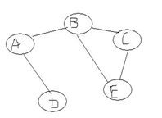
‘
In the above given network If user A wants to get acquainted with C there are couple of friendship flows existing like A-B-C and one more friendship network like A-B-E-C, so the optimal way for user A to get in touch with user C is through A-B-C network and friend finder helps to find this shortest network flow between any two user.

